How Mistakes in Meiosis Can Result in Down Syndrome or Death of an Embryo

A child with an extra copy of chromosome 21 in each cell has Down syndrome. A child with Down syndrome often has slower mental development, a flat face, and heart defects.

Down syndrome is generally not inherited from the child’s parents. Instead, the problem begins with a mistake in meiosis.

This figure shows how mistakes in meiosis can result in gametes with too many or too few copies of a chromosome.

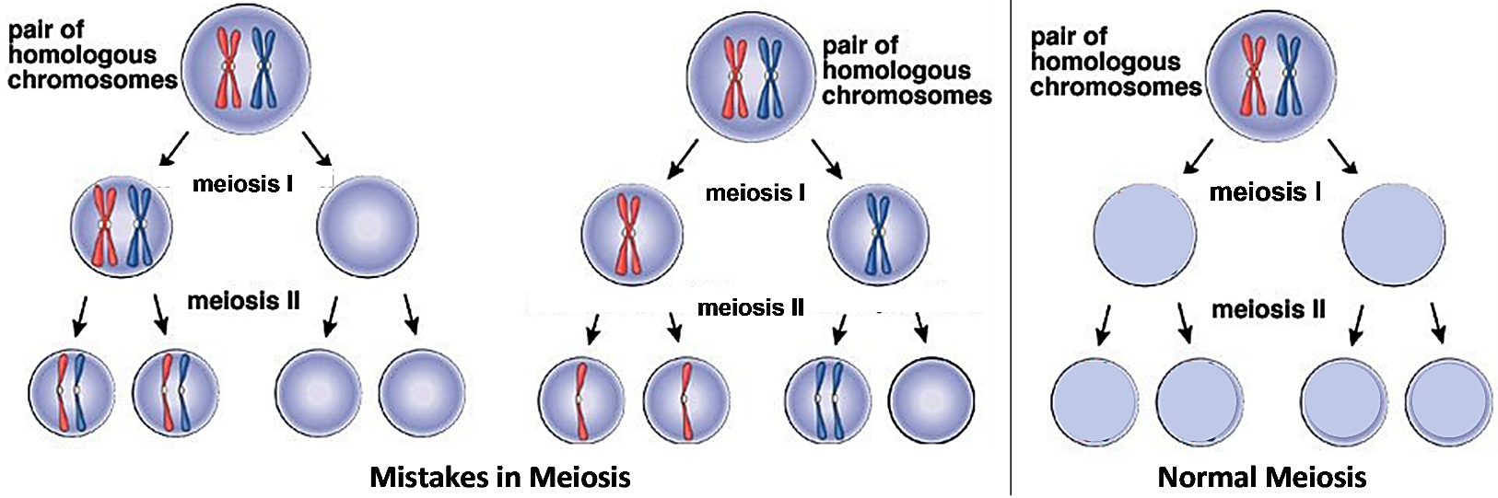

1a. In the diagram on the right show normal meiosis.

1b. Label the row that represents the gametes.

2a. Suppose that each gamete in the figure shows the number of copies of chromosome 21 in an egg. In the space below, draw a diagram to show how a normal sperm could fertilize one of these eggs to produce a zygote that would develop into a child with Down syndrome. Show the number of copies of chromosome 21 in the egg, sperm and zygote.

2b. How would this zygote develop into an embryo with three copies of chromosome 21 in each cell?

This figure shows a karyotype for a normal boy. A karyotype is a picture of a magnified view of the chromosomes from a human cell, with each pair of homologous chromosomes arranged next to each other and numbered.  3. Draw an extra chromosome 21 to show the karyotype of a boy with Down syndrome. | 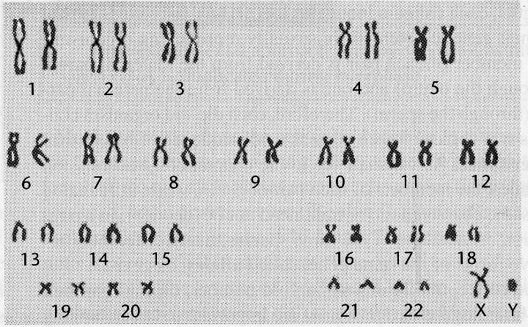

Each chromosome has specific genes with the instructions for making specific proteins. Normal cell function depends on the correct balance of the different types of proteins in a cell. Normal development of the embryo depends on normal cell function.

4. Based on the above information, suggest a hypothesis about how three copies of chromosome 21 in each cell can result in abnormal development.

5. Suppose that a zygote had only one copy of chromosome 21. Do you think that this zygote would develop into a normal embryo and child? Explain why or why not.

If each cell in an embryo has an extra copy of one of the chromosomes in the top row of the karyotype, the resulting abnormalities are so severe that the embryo always dies; this causes a miscarriage. Therefore, no babies are born with three copies of chromosome 1, 2, 3, 4 or 5 in their cells. In contrast, an extra copy of chromosome 21 results in less severe abnormalities so the embryo can often survive to be born as a baby with Down syndrome.

6. What do you think is the reason why an extra copy of chromosome 1, 2, 3, 4 or 5 results in more severe abnormalities than an extra copy of chromosome 21?

7. Clearly, Down syndrome is caused by a genetic abnormality. However, most babies with Down syndrome have parents with normal chromosomes, so Down syndrome is generally not inherited. Explain how a disease can be genetic, but not inherited.

by Drs. Ingrid Waldron, Jennifer Doherty, R. Scott Poethig, and Lori Spindler, Department of Biology, University of Pennsylvania, © 2020. This Student Handout and Teacher Notes with background information and instructional suggestions are available at https://serendipstudio.org/exchange/bioactivities/mmfmistakes .

